Danielle’s news 6th May 2020
Captain Tom Moore: second time hero
Captain Tom Moore helps the NHS after serving his country
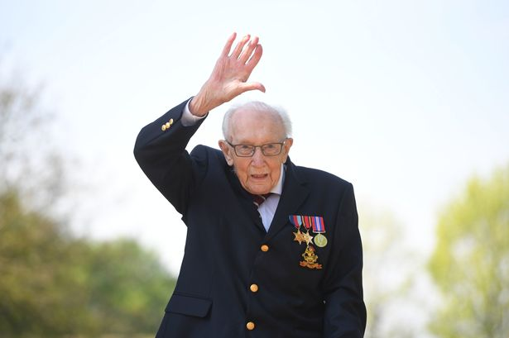
Captain Tom Moore has raised £32,796,405 he is a hero without a cape. Captain Tom Moore walked 100 lengths that is how he raised all the money for NHS ventilators. Tom Moore is a generous man and he is resilient for all he has done for NHS and serving his country. Tom Moore is an inspirational person, a fantastic role model for younger generations. Captain Tom Moore has become a colonel as M.O.D announces honorary promotion. Tom Moore and his positive and very selfless act has his whole country in awe of him, this is a major reason why so many people have donated money to his go fund me page. Tom Moore also had more than 40,000 birthday cards for his 100th birthday, this shows how much respect people have for Tom Moore. His family were so proud of him along with the Picture of Colonel Tom Moore
whole country especially the NHS.

