Leominster Primary School and Nursery

**Promoting Positive Relationships and Supporting Emotional Regulation Policy**



|  |  |  |
| --- | --- | --- |
| **Approved by:**  **Author:** | Mrs Helen Rees  and  Mrs Helen Lynch (Head Teachers) | **Date:** July 2024 |
| **Last reviewed by/on: May 2025** |  | |
| **Next review due by: May 2026** |  | |

### School vision statement

Philosophy of the policy at Leominster Primary School and Nursery:

At Leominster Primary School and Nursery, we believe that each person in the school has the right to feel safe, valued, respected and happy and for all children to learn in a calm and supportive environment. Everyone is expected to maintain the highest standards of personal conduct, to accept responsibility for their behaviour and encourage others to do the same. We believe that this will support our children to learn to manage their own behaviour and to be responsible for their own actions.

At Leominster Primary School and Nursery, we recognise that understanding our emotions is a key aspect of understanding and managing behaviour. Through Emotion Coaching and being attachment aware, both pupils and adults are able to both manage their behaviour and to create an environment that is conducive to learning. We understand that part of our role, in partnership with home, is to help pupils to understand what is ok and not ok. Underpinning the behaviour policy is the belief that everyone can learn to self-manage/self-regulate their own emotions and behaviour. Through this we encourage reflective thinking and do not accept prejudice in any form. Ultimately, we wish to give our pupils confidence about their capacity to think for themselves and to make sense of their own lives and experiences, hopefully beyond school and into the “real” world”.

### Policy Statement

This policy is based on Guidance provided by Herefordshire Local Authority and has included input from: members of staff, representatives from the governing body, parents and carers and children at Leominster Primary school and Nursery.

This policy is developed to ensure guidance for staff in order to promote positive behaviour in school. The procedures and guidance in this document provide a consistent approach across the school and enables students, parents and staff to understand our approaches to the management of behaviour in school. It is also recognised that for some pupils, variance on these procedures will be made in order to meet any specific social, emotional, learning or other needs which require a personalised approach; guidance for this appears in the appendix and approaches can be discussed with the SENDCos, safeguarding team or member of SLT.

This policy is for all staff, pupils, parents and carers, Governors, visitors and partner agencies working within the school and provides guidelines and procedures as to how our school supports and responds to behaviour. All new staff will have an induction and all staff will receive regular training.

**Policy Aims and Objectives**

Our school is committed to the emotional mental health and well-being of its staff, pupils and parents/carers. We wish to work towards this in all aspects of school life, and to provide an ethos, environment and curriculum that supports the social, emotional and mental health of the whole school community.

It is acknowledged that members of the school community may have very different parenting experiences and views on behaviour. However, the aim of our Policy is to bring us all together to adhere to some basic key principles and practices that reflect our school ethos.

Leominster Primary School and Nursery treats all children with unconditional respect and has high expectations for both adults’ and children’s learning and social behaviours. Our school is calm and purposeful. It prides itself on excellent relationships and a high level of care. We understand that positive behaviour can be taught and needs to be modelled. We understand that negative behaviour can signal a need for support which we will provide without diluting our expectations.

* To provide guidance to staff, parents and carers, governors, and other stakeholders on how to support our children to manage and regulate their feelings, communicate their words and feel safe so they are ready to learn.
* To maintain a caring, orderly community in which effective learning can take place and where there is mutual respect between members
* To help children develop a sense of worth, identity and achievement
* To help all children to become self-disciplined, able to accept responsibility for their own actions and make positive choices
* To develop in all children the ability to listen to others; cooperate and to appreciate other ways of thinking and behaving

We hope to achieve these aims through a whole school behaviour approach, based on rights responsibilities and respect. Praise, rewards, privileges and positive role-modelling support the development of self-discipline and the capacity to make positive choices.

**The Relational Approach**

Relationships are vital for all children in our school. It is through relationships that children learn to feel safe, belong, understand themselves, others and the world. It is our way of being together that is most important. The relational approach is a universal approach to teaching and learning which influences whole school ethos, systems and policy as well as everyday practice. It is also a targeted approach to support those children who are most in need. Studying the features of secure relationships helps us to understand how we need to be in order to build relationships. In order to be effective it is necessary to be personally reflective about how we are in relationships: what we feel and think and how this affects our way of being and this is a key focus of our support for children within our school. For many children their needs will be best met through our relationships with them. There is a growing body of evidence indicating that relational approaches are vital in supporting children’s well-being, enabling them to settle to learning and be fully included in school. As with all support we have carefully considered how our relationships in terms of, our universal whole school and whole class approaches as well as targeted provision enhances the needs of our individual children. Our relational provision focuses on: • Developing Relationships – This involves building relationships, supporting inclusion and setting and maintaining boundaries with empathy. • Responding and Calming – Using relational skills to keep things calm, using co-regulation skills in order to regulate strong emotions and developing skills and plans to manage crisis. • Repairing and Restoring – Using restorative conversations as part of our daily interactions to support a harmonious environment, facilitating restorative encounters to resolve conflict and harm and to support change.

**Rationale**

At Leominster Primary School and Nursery, we want our Policy to reflect our insight and understanding of the needs of our children and how this contributes to supporting children to be able to regulate their feelings and communicate their words in a positive manner so they can be ready to engage with their learning.

It is imperative we offer our children the security and relationships needed to meet their individual wellbeing and metal health needs and guide them along their journey in becoming independent, resilient, life-long learners. We incorporate a holistic, whole-person approach to ensure we are reflecting and planning for the needs of all our children, some with complex layer needs. We consider that behaviours, which challenge always happen for a reason and may, in that moment, be the only way a child can communicate. Children who display, or are at risk of displaying behaviours, which challenge may need support which involves both positive support and intervention and also some form of restorative practice.

Behaviour is a means of communication – we must ensure that all children are supported to communicate their needs safely and appropriately using their preferred communication systems.

Children are happy when their needs are understood and met and when expectations are clear.

This allows them to behave well and access opportunities and learning that school provides in their most well-regulated state possible. Their effort to manage themselves and their behaviour should be recognised and acknowledged by adults and their peers. Children can learn to improve how they communicate their feelings and words. Learning new behaviours is a task, just like learning to read and write. Children need a personalised approach to support them to manage their feelings and communicate their words respectfully. The more challenging pupils’ behaviour becomes, the more personalised an approach the pupil requires. Mistakes are part of the learning process and we recognise that all of our children are at different stages of the developmental process. We don’t make a judgement about it; instead we support and guide our children to get it right.

(See appendix 1 for Restorative Justice Conversation Framework) All adults can learn strategies to support all children to manage their feelings and communicate their words respectfully. All adults use personal and professional experiences and training as well as experiential learning as an opportunity to learn, understand and have insight into why our children demonstrate various behaviours. In order to work collaboratively with our children, their parents/caregivers and other professionals may need to develop strategies as part of a positive behaviour support plan (see– Stage 2 – Graduated Response) to support them to manage their feelings and communicate their words in a positive manner. It is imperative that a child’s behaviours are not excused but are seen as a skill requiring improvement. Although there are some pupils with SEND needs who may need a more personalised approach (see Stage 3 Graduated Response), these pupils are still expected to be able to learn to manage their own behaviours.

**The quality of our provision**

At Leominster Primary School and Nursery, we encourage staff to reflect on what may be the underlying issues that drive or trigger behaviours in children, and to think about ways of responding to behaviour that challenge in a non-judgemental and supportive way. We have communication systems in place and readily available when a child is demonstrating challenging behaviour. In this heightened moment, this is their “voice” and should be accessible at all times, but especially during times of dysregulation or distress when it is often difficult to make use of other communication methods. We personalise learning to ensure that we meet each child at his/her individual point of development in order that optimal learning takes place. We actively teach our children behaviour for learning in order for them to manage their feelings and communicate their words in a positive manner. Where necessary, we seek support from wider professional networks to problem-solve and develop our understanding of behaviour that challenges and also to ensure a personalised approach has been undertaken.

We consider what might be behind the behaviour; why the child is behaving in this way. There will always be a reason, the behaviour is a symptom of something that we need to identify, understand and correctly support. We keep our word and if, for some reason, we are unable to honour a commitment to a child, we communicate clearly and honestly why this has happened.

We apologise if we make a mistake – we are modelling this for children, and this will support us to build trust and respect.

We name and manage our own emotional reactions to a child’s reactions/ behaviours, i.e. we demonstrate emotionally intelligent reactions/behaviours at all times. We seek help if we are finding it difficult to manage our feelings about a child.

We are always respectful to children; we do not talk about them over their heads or in front of other children.

We consider the quality of our relationships with parents and carers as being vital. It is important to reflect and plan with parents to ensure consistency in approaches between home and school.

We support one another in managing our own emotions and know that regulating our own emotions is hard work.

**Routines**

Our consistent whole school routines support our children to understand expectations, manage anxieties, and mentally and physically prepare themselves for their day. This allows them to engage more fully with learning, manage their feelings and communicate in a positive manner. Behaviour for learning routines are explicitly taught – we do not assume our pupils know them.

We teach routines for all activities. The more consistency there is over routines, the easier it is for our children. Routines support children with their emotional development and behaviour for learning.

We continuously reflect on how we support children to adapt to changes to routines and how we prepare them for changes, as this is an important life skill. Changes to routines are practiced allowing our children to learn that changes can be managed in a positive way.

**Descriptive Praise**

We make every effort to tell children what it is exactly that we like about what they are doing; reinforcing the behaviours we want to promote, e.g. “I like how you used your communication book to tell me how you are feeling.” “I like that you asked for a break when you needed it.” “I noticed you were being a good friend by helping Sam.” “Thank you for coming back to your work so quickly.”

We give positive feedback and personal recognition. This raises their self-esteem and leads to management of feelings and communication in a positive manner. The use of descriptive praise is a feature of Leominster Primary language.

Descriptive praise supports emotional development and behaviour for learning.

We continuously identify the strengths of the child – we identify these with the child where possible and build on it. Children and Significant Number of Incidents We ensure that adults and children begin each lesson afresh with optimism and encouragement for success.

**Expectations**

Consistent routines

Through teaching and promoting the core values, children at Leominster Primary School and Nursery, learn that to achieve well and succeed in school they must work hard, concentrate and persevere when faced with difficult challenges. To do this the climate and ethos in the classroom needs to promote good behaviour for learning. To ensure this is able to happen every day, in every lesson, teachers always ensure that the classroom is calm, well organised, resources for lessons are prepared and all classes have established routines that maximise learning time. When a teacher inherits a class at the beginning of the academic year or at another point in the year, the class teacher must develop effective class routines and expectations. This is developed in collaboration with teacher / pupils and agreed by all. Pupils are clear about steps that may need to be taken if expectations are not met.

**Logical / Natural Consequences**

We do not believe in sanctions or punishment.

We do not punish children. However, it is important to understand that children may require additional time to catch up on work or require additional intervention to reflect on any inappropriate reactions displayed when aiming to manage and communicate their feelings -.

We use logical / natural consequences to help educate the children about their behaviour. This is often best carried out immediately but when necessary, these conversations may happen sometime after an event, when the child is better regulated and able to reflect upon their behaviour/reaction allowing them to participate fully in the process. The consequence needs to be a logical / natural consequence, to support the learner’s understanding of both positive and negative consequences.

We take a consistent approach when supporting children to manage their feelings and communicate their words in a positive manner in school. We are committed to follow this policy and use the Graduated Response stages below charts to support it.

Graduated response stage 1

|  |  |
| --- | --- |
| Step 1  Emotion coaching | Staff will follow the 4 steps of emotion coaching (appendix 2) to identify the emotion behind the behaviour  This can then lead to RESTORE (Restorative justice conversation) |
| Step 2  Regulation Station | If this is needed for the child to regulate their emotions. This can then lead straight to RESTORE (appendix 3 – what a regulation station looks like) |
| Step 3  Time IN | Short time IN with another adult. A time to calm, breathe and reflect. This can then lead to RESTORE. |
| Step 4  Escalation | If a child’s behaviour is persistent/ continuous/ extreme a member of the senior leadership team or behaviour support team should be called to support and enforce the natural consequence and the next steps. |
| Step 5  RESTORE  (Restorative justice conversation) | This needs a discussion at break time. If step 4 is reached, then maybe a more formal meeting is needed. Natural / Logical consequence is completed and further restoration if needed. |
| Parents/Carers | If step 4 is reached on more than 2 occasions in one, week parents and carers must be informed so the child can see that home and school come together to support. A emotional support plan may be needed at this stage. |

Graduate response stage 2

|  |  |
| --- | --- |
| Emotional support plan | |
| Emotional support | In discussion with the SENCO and SLT an emotional support plan needs to be in place and reviewed regularly. |
|  | Escalation requires a review of the emotional support plan and strategies that have been used with parents, SENCO and SLT |

Suggested support for Graduated response stage 2

|  |  |  |  |
| --- | --- | --- | --- |
| Early Help, SEND or School Effectiveness Team | EARLY HELP/WEST/ELSA/Nurture  If a child’s needs are broad and not mainly around educational needs (or needs are unclear) then the school will use the Early Help in order to support the child and their family.  The purpose of the Early Help Assessment is to gather a holistic view of a child’s needs that require a coordinated short term plan of action to address them. Parents are fully involved in this process and reviews take place regularly. This process is monitored by the Parents / Carers, safeguarding team, Assistant Heads, Safeguarding Team  It might be deemed appropriate for an SEMH identification (Boxall profile) | SEND SUPPORT  Pupils are considered to have SEND if the following applies: The pupil’s progress • is significantly slower than that of their peers starting from the same baseline • fails to match or better the child’s previous rate of progress • fails to close the attainment gap between the child and their peers • widens the attainment gap If the above criteria applies, the SENDCo, In partnership with parents, school staff and other outside agencies will put in place a Learning Support Plan or My Support Plan in order to work towards specific outcomes. This process is monitored by the SEND team. Additional interventions are put in place and other professional | School Effectiveness Team SUPPORT  Pupils will be referred to the Local authority team in partnership with the parents, school staff to help support them and us. |
| If, despite the above support being put in place alongside advice from School Effectiveness Team, the behaviours continue to persist a Pastoral support Plan needs to be put into place, followed by an EHCP of necessary. | | |

We avoid using consequences that involve taking away a previously earned privilege or any intervention time.

We always avoid speech which could lead to shaming or humiliation of the child. We understand that such approaches are detrimental to the child’s self-esteem and wellbeing and can escalate situations/incidents.

We recognise that a ‘one size fits all’ approach to natural consequences is not appropriate for our children. We consider developmental age and any additional or specific needs of the child when deciding appropriate natural consequences.

We use a plan, do and review approach to ensure children will not be given natural consequences that impede their future learning. This is monitored closely when we are discussing incidents with children, we deal with it in a non-judgemental way. For positive communication we use restorative questions.

When discussing behaviours/reactions we make reference to the health and safety and the impact the situation may have had on all involved and in the vicinity.

Our scripted restoration approach is as follows:

• Start by recognising their feelings and showing some empathy (if necessary and relevant) Emotion coaching 4 steps.

• What happened?

• How did it make ……………. feel?

• How do you feel?

• How can we fix this?

• What would you do next time/differently? We use scripts to aid our consistency as we respond to crisis moments; as we hold restorative conversations

**When we involve colleagues, we have three possibilities:**

1. Time IN: Child sent to colleague, but not to discuss how they managed their feelings and communicated their words, rather simply to supervise the child until the teacher has time to speak to them.

2. United front: Support requested from colleagues to stand alongside in response so that the child sees the united front.

3. Escalation: SLT / Behaviour Support Team involvement due to persistent/continuous/extreme behaviour. SLT now enforces natural consequences and next steps, along with teachers/staff.

**Reflection**

We strongly believe that it’s important for our children to clearly link a specific behaviour with its consequence. We do this using restorative language. There may be times when a child requires additional reflection time. During this time, we guide and support the child to help promote children’s awareness of behaviours. After a child completes reflection time, we aim to repair and restore the staff child relationship, and any other harm caused to others. We praise his or her behaviours at the first opportunity to reduce the attention away from any management of feeling and communication in a non-positive manner. We reassure the child that the management of feelings and communication in a non-positive manner has been dealt with and that we will all move on and start afresh. We constantly review what has happened and identify if there was anything that could have been done differently to support the child to manage. We offer ‘Time to Talk’ sessions with our mentors.

**Reparation**

Reparation means repairing relationships, or ‘making good’ in some way. We believe that our children should always be given the opportunity to repair, and that they want to do this. We do not believe in the concept of punishment, because it focuses the learner’s mind on punishment, rather than what she/he did. This frequently leads to children feeling angry about the punishment, rather than thinking about the impact of their behaviour on others and learning from the incident. Where developmentally appropriate, we support children to take responsibility for what they have done and to repair it with the other person(s) involved/ affected.

Even children with complex difficulties can be supported to repair; this will look different for each learner. We don’t make assumptions about what children feel. We understand that unresolved difficulties can make children very anxious and this can cause behaviours to escalate or become habitual.

There will be times when children may display signs/symptoms or react differently to a situation which is deemed as their ‘norm’. For some children it may be a ‘one off’ bad time/day however, for others it may be a sign they are struggling to manage their feelings and communicate in a positive manner. We believe communication with parents/carers is vital, with support from SLT. Contact home to discuss displayed behaviours/reactions and ways to move forward

There may be times when it is in the best interests of a child that they have supported time away from their class. This will be explained to the child and their parents/carers by class teacher/member of SLT. Graduated Response – Stage 2. Critical Incidents In cases of absconding, assault, bullying including cyberbullying, damage to property, racism and homophobia, we believe it is imperative to ascertain reason and level of understanding of the child.

The incident will be recorded on Bromcom and the safeguarding team and/or SLT will inform parents/ carers. We ensure that reflection occurs. The incidents and next steps will be discussed with a member of SLT, and parents/carers updated. Formal procedures may need to be undertaken in accordance with the guidance set out by the Local Authority.

**Recording Incidents**

At Leominster Primary School and Nursery, we monitor child incidents records on Bromcom and if deemed appropriate, My Concern. This helps us to highlight areas of concern.

Safeguarding Duties at Leominster Primary and Nursery, all staff are responsible for considering whether any changes in behaviour gives cause to suspect whether a child is suffering or is likely to suffer significant harm. If such suspicions exist, we follow the school’s safeguarding procedures. We will also consider whether continuing disruptive reactions might be the result of unmet educational or other needs. At this point, we will consider whether support systems are needed to be put in place and whether liaising with external agencies is necessary or appropriate, whilst referring to the Safeguarding and Child Protection Policy.

**Promoting positive behaviours**

Key Stage School and Class Assemblies: These cover areas such as ‘Caring for Others’,

‘Anti -bullying week’, How to be a good friend’, ‘Who to go to if you need help’. There is a plan for the year with themes for each week which will include specific issues relevant to our school and community including: Racism; Homophobia; Gender based language; Tolerance and respect; Disability awareness and a value of the month

* PSHE– children have 30-60mins of lessons each week which include strategies to deal with different situations and ways to help regulate emotions through the zones of regulation and body scanning. This is taught by the class teacher.
* Whole School days/weeks: Specific focus weeks are used to bring certain aspect a higher profile; these include: Children’s Mental health Week; Anti Bullying Week
* School Curriculum including RE and a thread through themes
* High focus on teachers developing positive relationships with children
* Clear and consistent routines in classrooms, around the school and in the wider community
* High expectations from staff about conduct in class and around the school
* Clear pathways when there is a cause for concern and positive reinforcement for good responses
* Upper KS2 pupils acting as role models (lunchtime monitors / prefects / play leaders
* Encourage all pupils to have a voice, to ensure all pupils feel part of our school community (school parliament / opportunities for pupil voice and questionnaires
* Mental Health / people of the week / House points / Rewards/class treats / dojos

### Roles and Responsibilities

It is not just the role or responsibility of a few key staff for dealing with behaviour in the school; it is a shared responsibility.

Responsibilities

All staff

* All members of staff are responsible for supporting the needs of children across the school. Where a child is seen to be having difficulties they should be treated with respect and understanding.
* Shouting and shaming should never be used and is not tolerated at Leominster Primary School and Nursery.
* Staff will always endeavour to have private discussions with pupils in order to help support any needs that are arising.
* Staff use the Key principles outlined in this policy to support the needs of all our pupils.

Specific Roles

**Teachers -**

Ensure parents are contacted when:

* a child is constantly reaching step 4,
* there has been a ‘one off issue significant incident

Where possible the teacher should maintain ongoing dialogue with the parents / carers. On some occasions a member of SLT or the Safeguarding Team, will liaise with parents for significant one-off incidences.

**Family Support Worker / Behaviour support staff / WEST / ELSA / Nurture**

Whoever is deemed appropriate to work with pupil:

* Provide specific support for children experiencing any difficulties, whether this is an ongoing need or a short term difficulty a child may be having (At home or at school)
* Provide support in class and at break and lunchtimes
* Provide 1:1 or group work to support emotional health needs and mindfulness
* Use the nurture room / Sensory room

**SLT / Safeguarding Team / SENDCOs**

* Lead the ethos of this policy
* Ensures the policy is implemented effectively
* Ensures effective training for staff
* Oversees the specific needs of pupils across the school
* Provides support to staff, pupils and parents as necessary
* Links with outside agencies to offer additional services
* Ensures that all tracking and reporting of incidents and additional needs are up to date

**Head Teacher’s and Governors**

* Lead the ethos of this policy
* Is the only person authorised to exclude a child

**Parents**

* Inform the school of any concerns (Class teacher, SLT, Safeguarding Team)
* Have an open dialogue with the school
* Support the school when needing to get further support
* Setting down these general guidelines on policy and of reviewing the effectiveness of this
* Duty to consider parents’ representations about an exclusion

**The role of Herefordshire Council**

Attachment training provides an understanding of early child development and the importance of nurture on the developing brain. It focuses on how to support teachers and key adults in understanding challenging behaviours and provides strategies to support children to regulate and manage their emotions more effectively. The training offers advice on establishing a key attachment relationship. It also provides staff with strategies to support children to regulate and manage their emotions more effectively. It uses the principles of Emotion Coaching and attachment theory.

All Herefordshire maintained schools are encouraged to self-evaluate alongside their EP using the Attachment Audit. and to support our school through the ARC accreditation process if they wish. Please refer to this Guidance as well as Appendices.

**Team Teach**

In some circumstances, staff may use reasonable force to restrain a pupil to prevent them:

* Hurting themselves or others
* Damaging property

Incidents of Team Teach will always be used as a last resort with the minimum force and for the minimum amount of time possible. Incidents will always be logged and reported to parents.

**Bullying and Child-on-Child Abuse**

We define bullying as a repeated act of conscious verbal or physical hurt caused by an individual or group. It is NOT the occasional hurtful comment or action of another; we understand that children have to grow up in a world that is far from perfect and in which not everyone will behave towards us as we like. Resilience and appropriate responses are important. However, ‘bullying’ is serious and the school does everything that it can to ensure that it is prevented and that it stops. We encourage children to tell us how they are feeling and endeavour to build a community of trust in which individuals are able to talk to their class teacher or another adult. We want parents to know that they can discuss any concerns about bullying at any time (see Child-on-Child Abuse policy / Antibullying Policy). The school is clear that any form of Child-on-Child Abuse is unacceptable. The measures set out in this Behaviour Policy and the school’s Safeguarding and Child Protection Policy ensure that incidents of child-on-child abuse are prevented and addressed quickly and efficiently.

**Racist incidents**

Comments of any sort are totally unacceptable. They are dealt with in school and reported to school governors.

**Mobile phones**

We have a clear approach prohibiting the use of mobile phones in school throughout the day (see our mobile use policy) Children are encouraged to keep mobile phones at home. If a child requires a mobile phone to be brought to school, they must hand it in to the school office for safe keeping as soon as they enter the premises. It can be collected at the end of the school day. Children should not be using a mobile phone in school.

**Searching, screening and confiscation**

Detailed guidance for schools can be found in Searching, screening and confiscation at school. It identifies prohibited items such as:

• Knives and weapons

• Alcohol

• Illegal drugs

• Stolen items

• Tobacco

• Fireworks

• Pornographic images

• any article that the member of staff reasonably suspects has been, or is likely to be, used to commit an offence, or to cause personal injury to, or damage to the property of, any person (including the pupil)

**Suspensions and Exclusions**

The Headteacher’s and Governors (Primary) can suspend a pupil from school, but avoid this where possible. They may suspend a pupil for one or more fixed periods (which cannot be extended) for up to 45 days in any one school year. At the time of a suspension, parents and carers will be informed if there is a possibility that the suspension may become an exclusion. The Headteacher’s may exclude a child permanently.

### How the school supports staff well-being and reflection

The link between emotions and learning is evident.

We provide emotional support for staff to help manage stress and secondary trauma, and to reduce the likelihood of staff burnout.

* The school medical insurance support
* The school has a mental Health Lead Champion and a mental Health working party
* Gore Langton and boy (2017) includes some very helpful resources e.g. resource 11.5 – self-care tips for teachers and resource 11.6 supporting staff tracker

**Practice and policy review process**

School Review:

This will be continuous (and at least annually) process of review of our school’s

Relational Policy. It will involve an ongoing cycle that involves applying Attachment Aware principles into practice and policy development, disseminating through frequent training, reviewing effectiveness/identifying weaknesses and/or lack of clarity, problem-solving to further develop practice.

**Appendix 1:**

Restorative conversation Restorative Conversation (structure not a script)

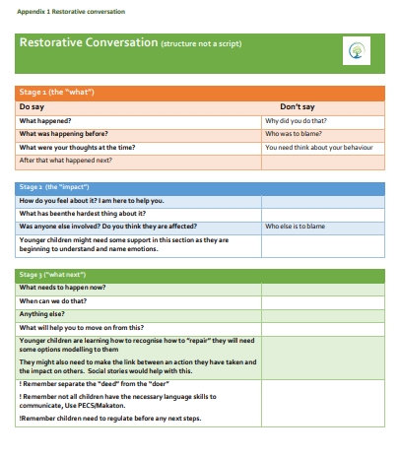

**Appendix 2**

**Emotion Coaching**

**Emotions**…we all have them. Everything we do and everything we learn is shaped in some way by the way we feel. Feelings are a natural part of who we are. But how do children and young people learn about emotions? How do they learn to understand their sadness or joy? What is appropriate behaviour when these feelings are strong? What can a parent do when a child or young person explodes in anger or hides in fear? Parents and teachers spend lots of time teaching children and young people important things such as reading or tying shoes. Taking time to help children learn to understand their feelings is important too.

Research shows that children and young people who understand their feelings and learn about their emotions have these advantages:

• They form stronger friendships with other peers.

• They calm themselves down more quickly when they get upset.

• They do better in school.

• They become empowered to problem-solve.

• They become more resilient when things go wrong.

**Becoming an Emotion Coach**

Emotion Coaching is a practical approach that helps children and young people understand their feelings ‘in the moment’. Through Emotion Coaching they learn how emotions work and how to react to feelings in healthy ways. This can take time but can help to strengthen a relationship with a child and prepare them for the challenges life can bring.

**The Four Steps of Emotion Coaching**

**Step 1**: **Recognise and empathise with the feelings**

* This takes place before you say anything to the child or young person.
* Pay attention to emotions, from happiness to sadness to anger.
* Observe, listen, and watch for changes in facial expressions, body language, posture, and tone of voice.
* Show your child that you understand what he or she is feeling.

**Step 2**: **Label and validate the feelings.**

* Identify and help to name the emotions your child is experiencing. For example, “You have gone all quiet. I wonder whether you are worried about something….”
* Telling him/her that you understand the situation and that the feelings are OK.
* If possible get in there sooner rather than later i.e. before levels have escalated to a crisis.

**Step 3**: **Set limits on behaviour (if needed)**

* Carry this out when the child is calmer.
* Find somewhere else to go if appropriate e.g. let’s sit over there to discuss this.
* Keep the feelings and behaviour separate. For example, “I know you are feeling angry because you wanted to finish the game you were playing. Throwing the game was not okay because it has to be tidied up and it’s time to go out.”

**Step 4:** **Explore and agree solutions for the problem**

* What did he/she want at the time things went wrong?
* Helping children think through possible solutions to this.
* If they are stuck, be ready to offer them some suggestions
* Talking ideas through with questions such as “will it work?”, “how will you feel?”, “how will it make others feel?”
* Help your child to feel positive about the outcome.
* When appropriate, reviewing alternative ways of handling a similar situation next time

**Appendix 3**

**Regulation station**

Each class should have a designated area for pupils to be able to regulate their emotions.

In order to be consistent, the area should include:

* A table and chair
* Title of area “Regulation Station”
* Zones of Regulation which should include the ability for the pupil to be able to identify and place their own emotion
* A box of breathing techniques / age-appropriate fidget toys / laminated social stories
* Dependent on the age / SEND need of the class – should include appropriate resources for those pupil

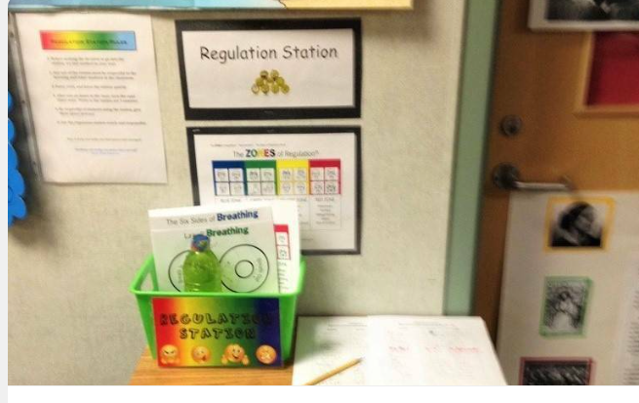

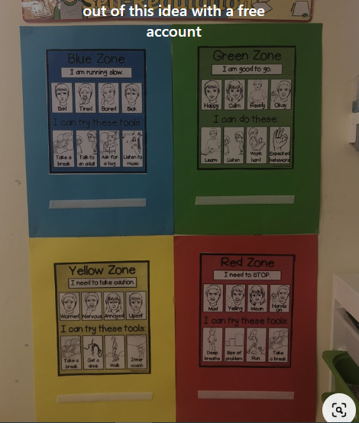

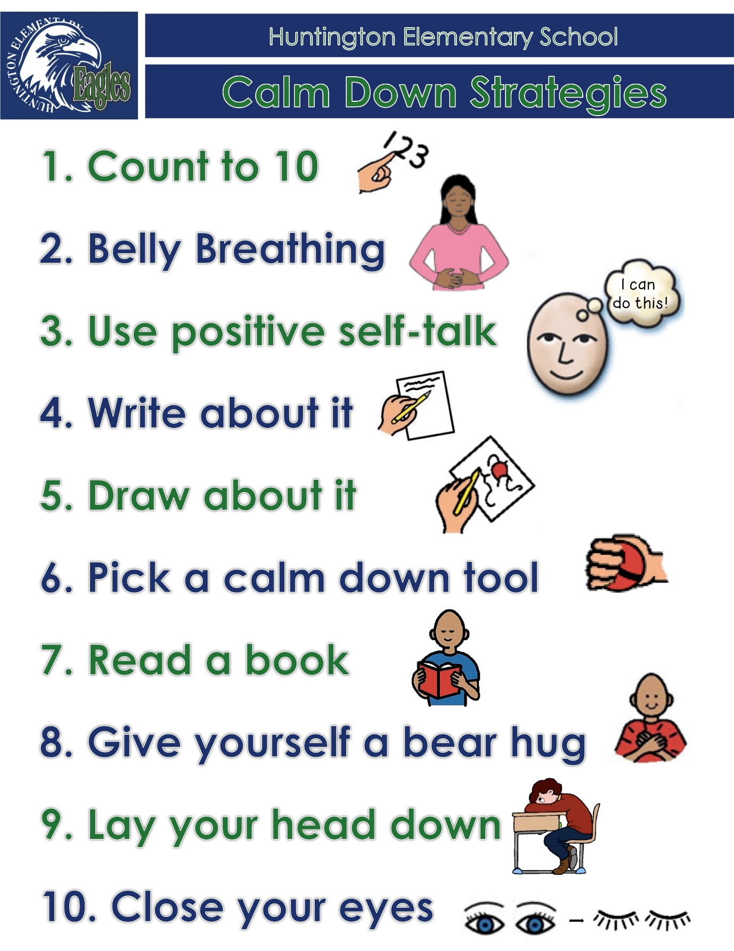

**Appendix 4**

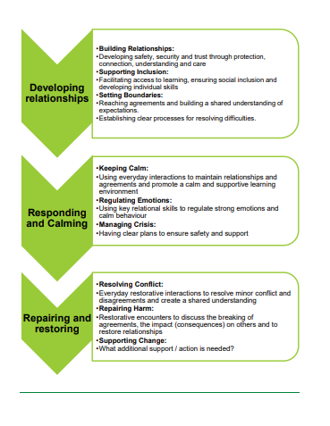

**Appendix 5**

**Top Tips for implementing an Attachment Aware Approach**

**Recognise behaviour as a form of communication**

Consider what might be underpinning a children and young people’s behaviour. Don’t immediately seek within-child explanations - e.g. labels such as ADHD, ASC. Consider the children and young people holistically/ in context. Their behaviour might be a very normal response to adverse life experiences.

**Promote a positive approach**

Spot children and young people behaving well/ doing the right thing. Offer specific and descriptive praise (or for those children and young people who find it difficult to accept praise, offer discrete non-verbal feedback). Avoid global statements such as “good boy”. **Differentiate expectations** –

How long should you expect a children and young people who is hypervigilant to sit still during carpet time or assembly?

What might be realistic expectations (in terms of approach to a task) for a children and young people who is terrified of failure?

Remember that work-avoidant behaviour can be linked to a fear of taking risks/feelings of vulnerability – even the risk of asking for help.

Model and explicitly teach what is needed for ‘readiness to learn’, including promoting a growth mindset approach.

Set up the expectations accordingly, so that children and young people aren’t set up to fail.

**Differentiate response**

Some children and young people perceive/experience public verbal reminders/prompts around expected behaviour very shaming. Consider non-verbal cues/gestures (agreed with the children and young people, which can also powerfully remind them that you are holding them in mind). Always ensure that any disapproval expressed is of the behaviour and not the person (i.e. maintain a sense of unconditional positive regard).

Relationships first!

‘Engage, don’t Enrage’ (Look at your own behaviour – can you remain open and engaged?)

‘Connection before Correction’

‘The 3 Rs: Regulate, Relate, Reason’ Remember empathy comes before limit setting/problem-solving around the behaviour. Use emotion coaching and attachment aware scripts – e.g. “I’m wondering if (you are shouting out “this is boring!” because) you feel scared about getting the answer wrong? I know what that feels like, it can be really scary to have a go at something, in case you might fail”.

A whole school approach

All members of staff are responsible for supporting the behaviour of children and young people across the school. Attachment/ building relationships is everybody’s business! The HT and SLT must lead the whole school attachment aware ethos to promote a consistent approach that is embedded across the school, through policy development, displays, choice of language, non-verbal behaviours, and communication with parents/carers, as well as those outside of the school community. One or two ‘key adults’ working to support a children and young people using attachment aware approaches is not enough. You need the whole school community to be signed up to an attachment aware approach

Use agreed tools for recording, monitoring and sharing planned strategies/support/progress around behaviour so that they can be consistently implemented.

Examples: Personal Education Plans (PEPs) for Children in Care and Previously in Care; Action and Progress Plans; Pastoral Support Plans (PSPs); Individual Education Plans (IEPs); Provision Maps; One Page Profiles. These should highlight strengths and areas of resilience - not just within child but also family/community factors. Include key triggers to avoid escalating situations (e.g. using a loud voice/ threatening body language/ publicly admonishing/ confronting). children and young people and their parents/carers need to be involved and central to this process. Consider who else might need to be involved in support – e.g. other key adults or agencies such as BeeU or Early Help

Small actions can make a big difference!

Even smiling at/greeting a children and young people on their way into school can really add to their sense of belonging/ feeling liked, respected and valued.

Don’t expect immediate results or returns!

A children and young people might be very dismissive of you behaving in a kind/empathic manner towards them, but this doesn’t mean that your actions weren’t important, or valued! It may just mean they are not in a good place to be able to receive kindness and/or that they need lots more experiences of this positive approach/kind behaviour to even begin to internalise a positive sense of self.

Expect sabotage from some children and young people and name it, where appropriate Dan Siegel’s ‘Name it to tame it’ and use the wondering aloud techniques. For example, “Amy, I am wondering if you trashed the room because it feels like too much pressure on you to keep showing such good behaviour all morning, and maybe you are scared of disappointing me or yourself?”

Recognise that what you feel is a likely indication of how the children and young people feels

If you feel helpless/stuck/frustrated/angry, this is often an important indication of how the children and young people is feeling inside and what they are projecting out.

Be cautious around suggestions of a ‘fresh start’

Often people start to look for fresh starts such as another school for a children and young people when they feel stuck. Don’t assume anyone else will be able to manage the behaviour any better/ feel less stuck! The problem just becomes someone else’s to deal with! Always consider whether this is really best for the children and young people. Often children and young people who unconsciously push others away through their behaviour are the ones who have experienced the most rejection and are most successful at being repeatedly rejected/ excluded. <http://northstarpaths.com/visuals>

**Appendix 6**

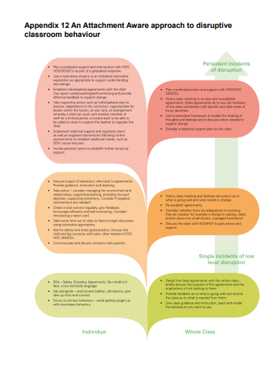

**Appendix 7**

