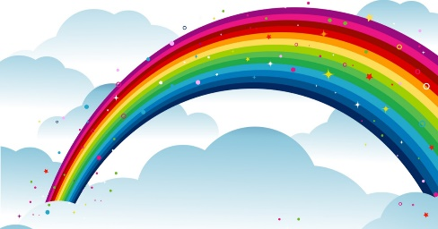
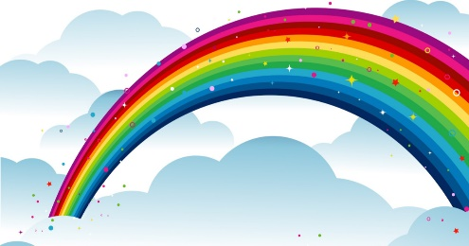
My Colour Poem

What is pink? A ______________ is pink

________________________________________.

What is red? A ______________ is red

________________________________________.

What is blue? A ______________ is blue

________________________________________.

What is white? A ______________ is white

________________________________________.

What is yellow? A ______________ is yellow

________________________________________.

What is green? A ______________ is green

________________________________________.

What is my favourite colour? The colour of ______________!

